ROSSMOYNE SHS SEMESTER 1, 2009
UNIT 2C MATHEMATICS EXAMINATION

SECTION B APPROVED CALCULATORS PERMITTED

STUDENT’S NAME _____________________________________

TEACHER:-
(Circle one name) KNOBLAUCH LONGLEY SUTTON TAY

TIME ALLOWED FOR THIS PAPER
Reading time before commencing Section A Five minutes
Working time for Section A (non calculator) Forty minutes
Changeover time between Sections A and B Five minutes
Reading time before commencing Section B Five minutes
Working time for Section B Eighty minutes
Available marks for Section A: 40 marks
Available marks for Section B: 80 marks

MATERIAL REQUIRED / RECOMMENDED FOR THIS PAPER
TO BE PROVIDED BY THE SCHOOL:
This Question/Answer booklet
TO BE PROVIDED BY THE CANDIDATE
Standard Items Pens, pencils, eraser, ruler
Special items Curriculum Council Mathematical Formulae and Statistics Tables Book, drawing instruments, templates, notes on two sheets (4 sides) of A4 paper and calculators (Section B only) satisfying the conditions set by the Curriculum Council.

NOTE: Personal copies of the Tables Book should not contain any handwritten notes, symbols, signs, formulae or any other marks (including underlining and highlighting), except the name and address of the candidate, and may be inspected during the examination.

IMPORTANT NOTE TO CANDIDATES

No other items may be taken into the examination room.
It is your responsibility to ensure that you do not have any unauthorised notes or other items of a non-personal nature in the examination room. If you have any unauthorised material with you, hand it to the supervisor BEFORE reading any further.

STRUCTURE OF THIS PAPER

This paper consists of two sections:
Section A is a non-calculator section – no calculator may be used in this section.
Time allowed for this section is 40 minutes. At the end of 40 minutes, this section will be collected by the supervisor. There will be a 5 minute changeover before commencing Section B.
Section B is a section where approved calculators are permitted. Time allowed for this section is 80 minutes. At the end of 80 minutes, this section will also be collected by the supervisor.

INSTRUCTIONS TO CANDIDATES
ALL questions should be attempted. You may answer the questions in any order you wish.
Write answers in the spaces provided. Extra pages are supplied at the back of this booklet. If the extra pages are used, label the questions clearly. Indicate on the original question that your working continues at the end of this booklet.

Show all working clearly, in sufficient detail to allow your answers to be checked readily and for marks to be awarded for reasoning. Incorrect answers given without supporting reasoning cannot be allocated any marks. If you repeat an answer to any question, ensure that you cancel the answers you do not wish to have marked.
SECTION B
APPROVED CALCULATORS PERMITTED FOR THIS SECTION
TIME: 80 minutes
MARKS ALLOCATED 80 marks
- [ 6 marks ]
- The points 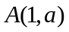 and 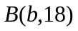 lie on the line 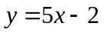.
  - Determine the values of a.
[ 2 ]
  - Determine the values of b.
[ 2 ]

- Find the equation of the straight line through the point 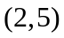 and parallel to the line with equation 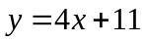
[ 2 ]
- [ 8 marks ]
- Find the equation of the line through the point (12,3) which is perpendicular to the line 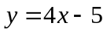.
[ 3 ]

- What is the gradient of the line which passes through the points 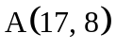 and 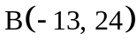
[ 2 ]

- What is the distance between A and B?
[ 3 ]
- 8 marks ]
For the graph 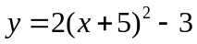
State
- the equation of the line of symmetry
[ 2 ]

- Whether y has a maximum or minimum value
[ 2 ]

- The co-ordinates at the maximum or minimum value of y
[ 2 ]

- The coordinates of the point where the graph crosses the y axis
[ 2 ]

- [ 9 marks ]
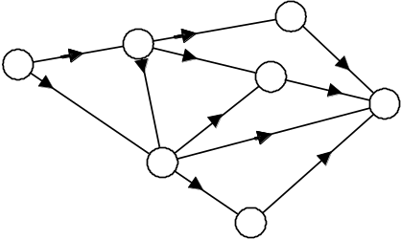Littleknown Airways has a network of destinations as shown in the diagram.

- Consider the diagram below. The number of passengers that can be carried on each route is shown on each arc. The arrow shows the direction of travel.
What is the maximum number of people that can fly from A to G? [Show working]
[ 5 ]
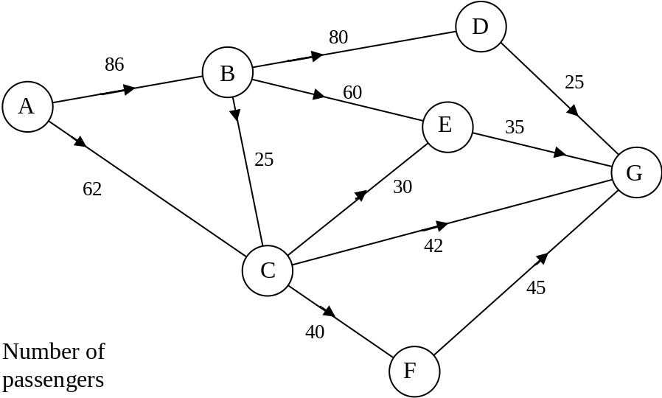

- A new plane is purchased so that from A to C, the number of passengers is increased to 100. What effect on the number of passengers able to travel from A to G
[ 2 ]
The diagram shows the distances (in kilometres) for each route.
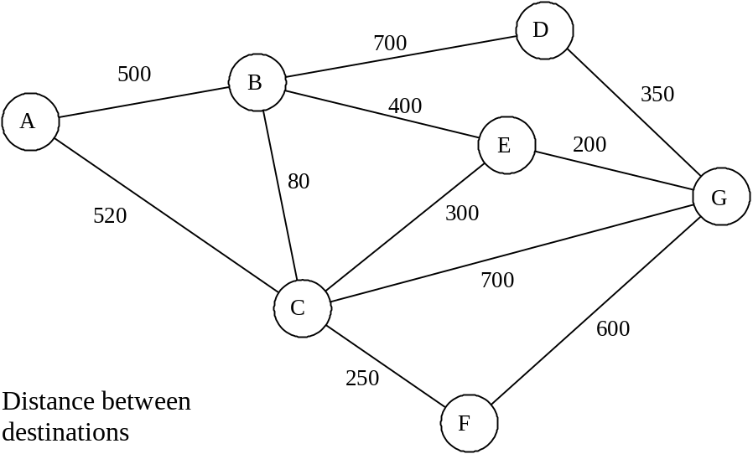

Littleknown Airways is bought out by a new company. The new company decides that it can only maintain those links between towns that form a minimal spanning tree.
- Draw the minimal spanning tree on the diagram below.
[ 2 ]

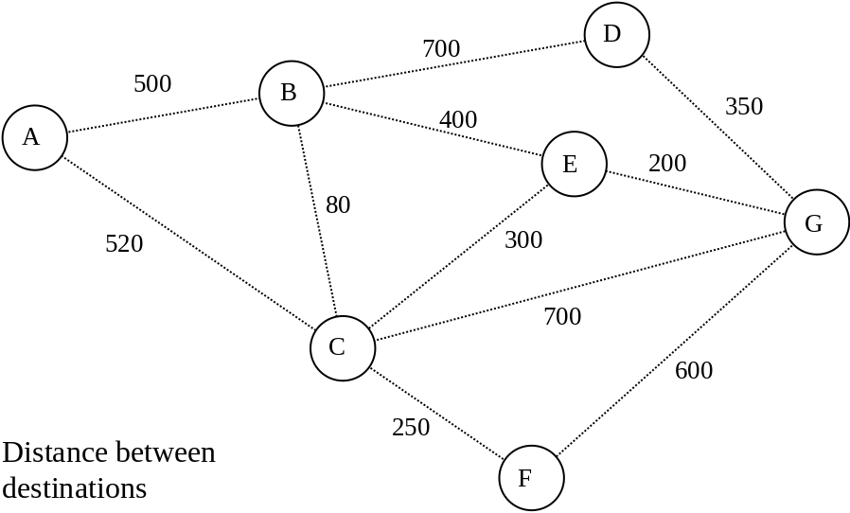
- [ 8 marks ]
For the graph 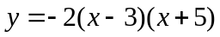
State
- the equation of the line of symmetry
[ 2 ]

- Whether y has a maximum or minimum value
[ 2 ]

- The coordinates of the point where the graph crosses the y axis
[ 2 ]

- The coordinates of the point(s) where the graph crosses the x axis
[ 2 ]

- [ 6 marks ]
The diagram on the right shows the motion of a stone thrown out to sea from the top of a cliff. The stone has an initial speed of 8m/s at 45° to the horizontal, from a position that is h metres above sea level. The equation of the path of the particle is 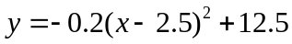 with x and y axes as shown in the diagram and 1 metre to 1 unit on each axis.
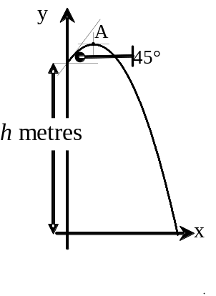

Find

- the coordinates of A, the highest point on the path of the particle,
[ 2 ]

- the value of h.
[ 2 ]

- How far is the stone out to sea when it splashes down?
[ 2 ]

- [ 9 marks]
Two 4 sided unbiased spinners are numbered as shown in the table.
- Complete the table below which shows the possible outcomes when the two spinners are spun.
[ 1]
 | BLUE SPINNER
RED SPINNER |  | 2 | 4 | 5 | 8
RED SPINNER | 2 | 2, 2 | 4, 2 | 5, 2
RED SPINNER | 4 | 2, 4 | 4, 4 | 5, 4 | 8, 4
RED SPINNER | 5 | 2, 5 | 4, 5 | 5, 5 | 8, 5
RED SPINNER | 6 | 2, 6 |  | 5, 6 | 8, 6

Let A be the event that the Red Spinner is 2.
Let B be the event that the sum of the two spinners is 10.
Let C be the event that the Blue Spinner is 8.

- Calculate
- 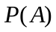
[ 2 ]

- 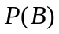
[ 2 ]

- 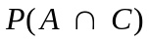
[ 2 ]

- 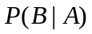
[ 2 ]

- [ 10 marks ]
  - In a study to find the relationship between hypertension and smoking habits the following data was collected.
 | Non-smoker | Smoker | TOTAL
Hypertension | 21 | 66
No hypertension | 48 | 45
TOTAL |  |  | 180
If an individual from the study is selected at random, calculate the probability that the person is
- suffering from hypertension given that the person is a smoker. [ 2 ]

- a non-smoker who does not suffer from hypertension.
[ 2 ]

  - In another study, this time of 300 people, the following information was collected.
- Exactly half the people suffered from hypertension
- The probability that a person suffering from hypertension is a non smoker is 0.20
- The probability that a non-smoker suffers from hypertension is 0.30
Use the information above to complete the table
[ 4 ]
 | Non-smoker | Smoker | TOTAL
Hypertension
No hypertension
TOTAL |  |  | 300

  - Comment on the statement "In the second study a greater proportion of non-smokers are suffering from hypertension".
[ 2 ]
- [ 6 marks ]
  - Percy bought a car 5 years ago for $35000 and expected that its value will decrease a steady rate of 8% p.a. He is now selling it. Assuming that his assumptions are correct, how much can he expect to get for it?
[ 3 ]

  - Unfortunately, Percy’s care of his car was not good and the best offer was $15000. What steady annual rate of depreciation does this drop in initial value represent?
[ 3 ]

- [ 6 marks ]

Tax rates 2008-09
Taxable income | Tax on this income
$0 – $6,000 | Nil
$6,001 – $34,000 | 15c for each $1 over $6,000
$34,001 – $80,000 | $4,200 plus 30c for each $1 over $34,000
$80,001 – $180,000 | $18,000 plus 40c for each $1 over $80,000
$180,001 and over | $58,000 plus 45c for each $1 over $180,000

The Australian government’s personal income tax charges appear in the above table.
- How much tax does a person with a taxable income of $60570 pay?
[ 3 ]

- How much will this person “take home” each week”?
[ 3 ]
- [ 4 marks ]
A loan of $25000 is taken with compound interest charged at 9.5% p.a. compounded monthly.
- Use the financial application in your calculator to find how much needs to be paid each month to repay this loan in 4 years.
[ 2 ]
- What is the total amount of interest charged for this loan?
[ 2 ]

THIS PAGE IS FOR EXTRA CALCULATIONS

